**PF LAB 04**

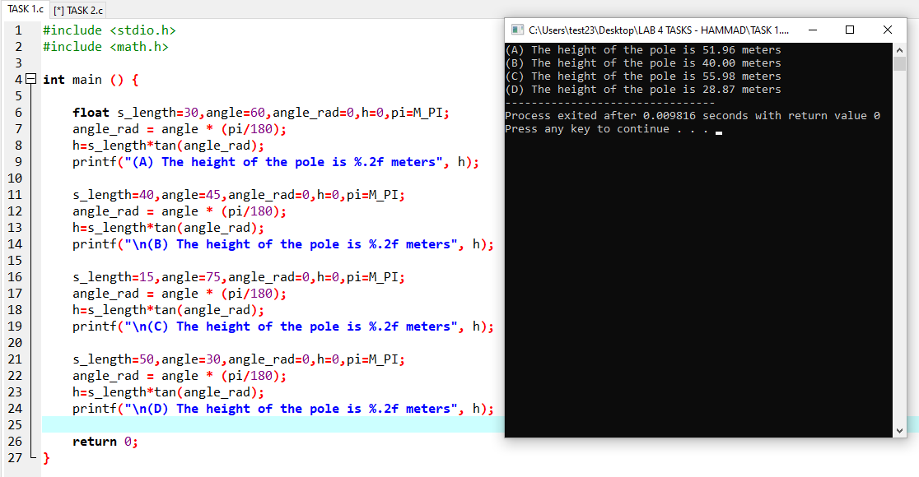**TASK 01:**

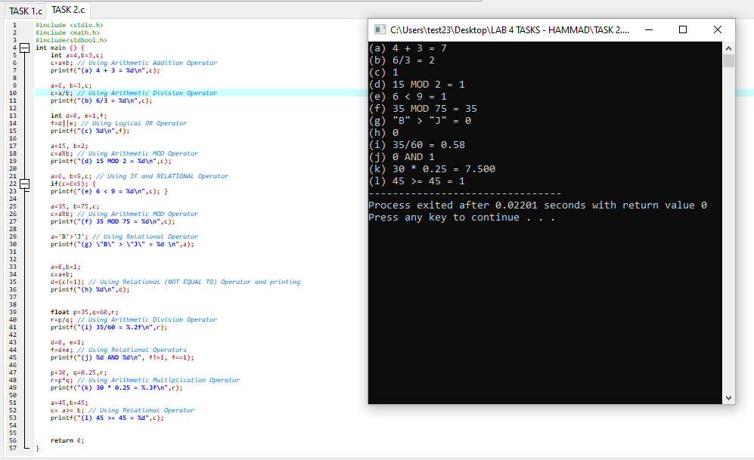**TASK 02:**

**TASK 03:**

The accuracy of floats is very less due to which they do not add up to the binary value of 0.3.

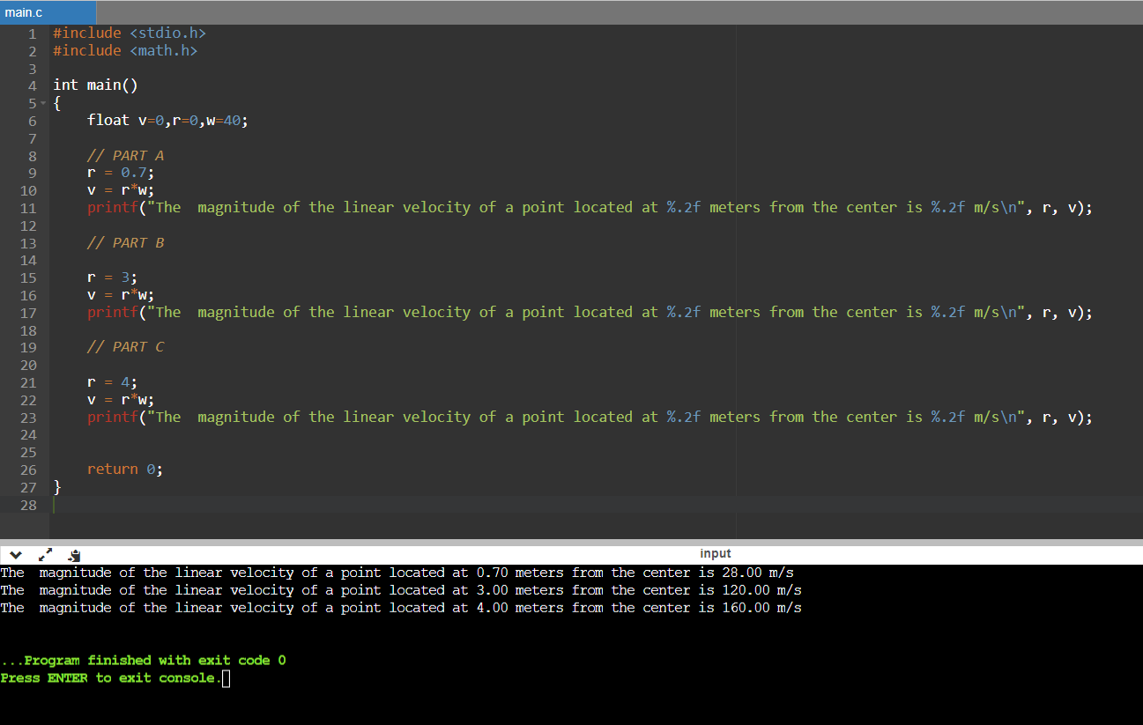**Task 04:**

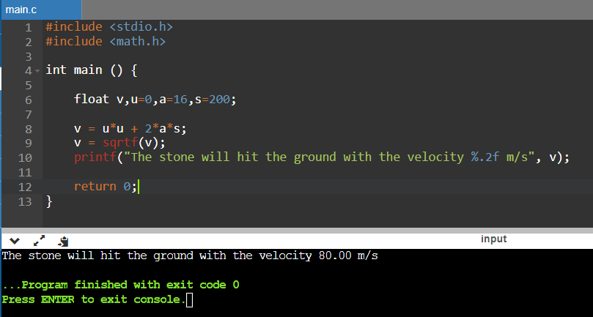**TASK 05:**

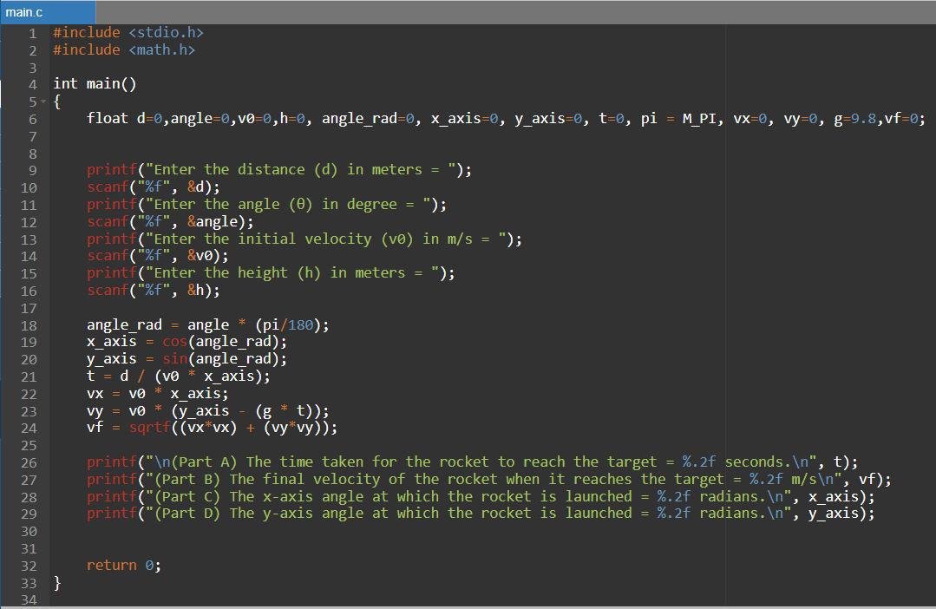**TASK 06:**

